1. Sales by Customer

<https://us3.ca.analytics.ibm.com/bi/?perspective=explore&pathRef=.my_folders%2Fsales%2Bby%2Bcustomer&subView=model0000018387c5baaf_00000000>

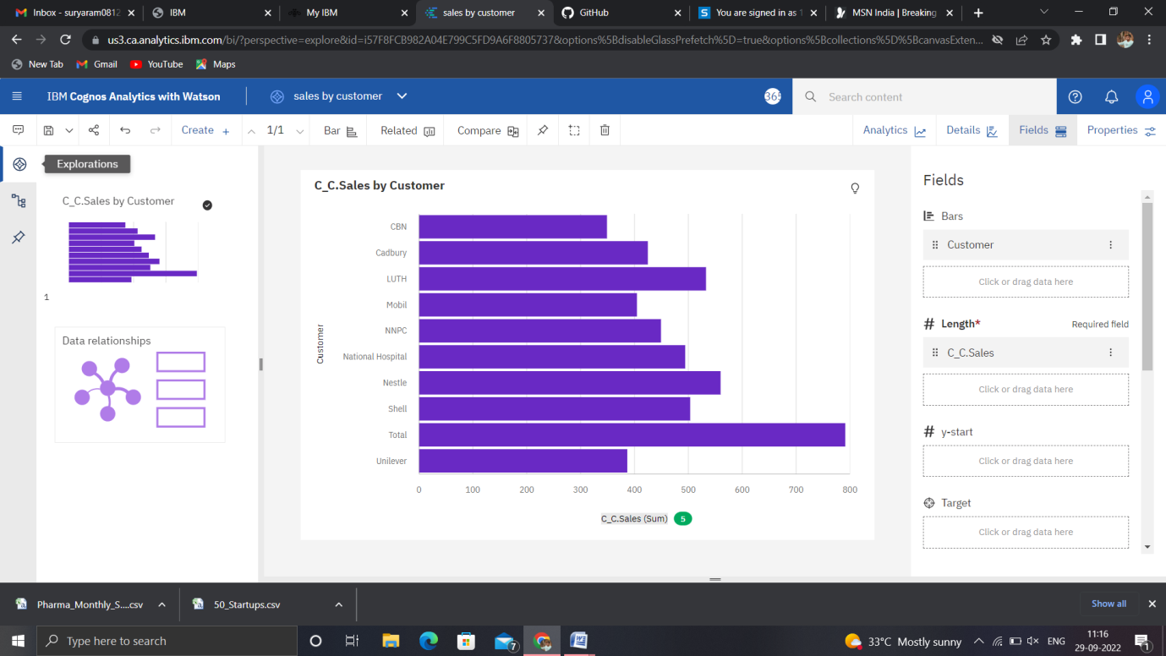

1. Sales by location

<https://us3.ca.analytics.ibm.com/bi/?perspective=explore&pathRef=.my_folders%2Fsales%2Bby%2Blocation&subView=model0000018387c89b33_00000000>

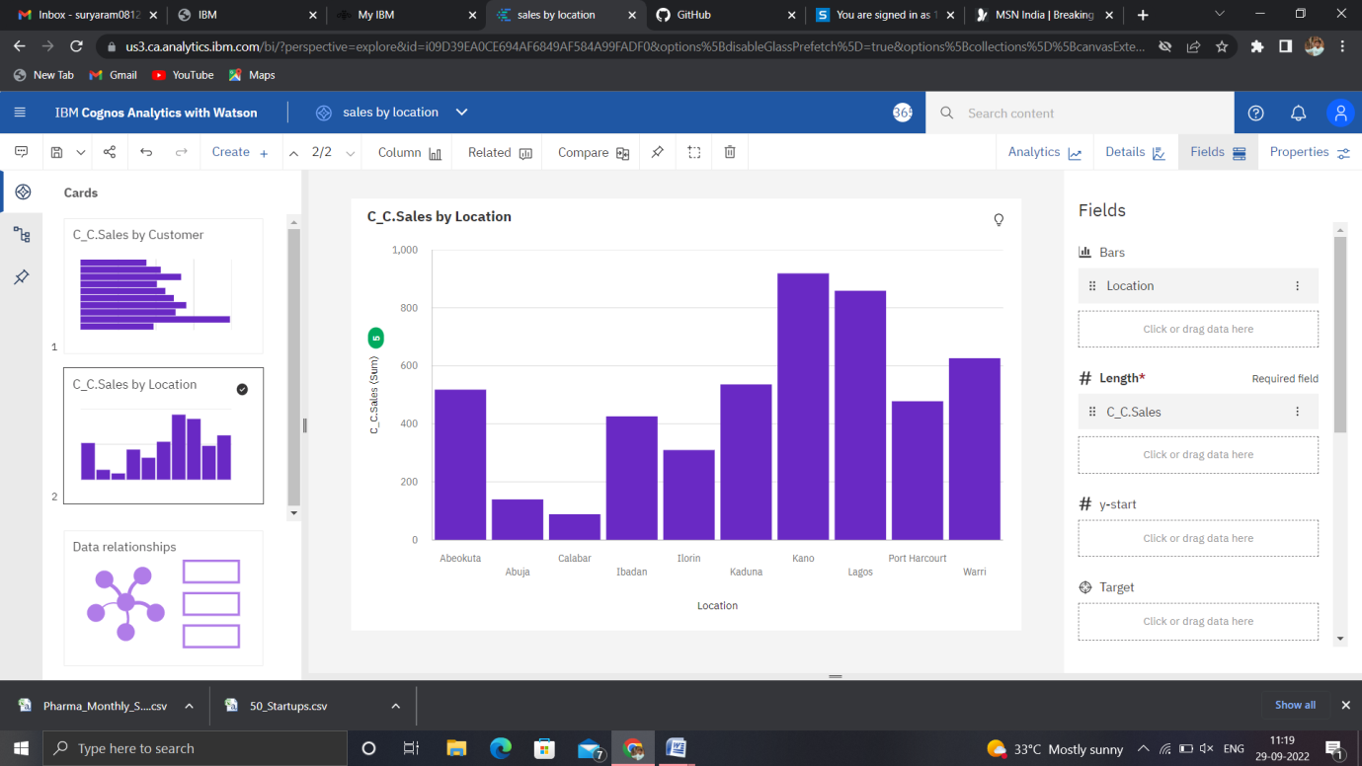

1. Sales by sales representative

<https://us3.ca.analytics.ibm.com/bi/?perspective=explore&pathRef=.my_folders%2Fsales%2Bby%2Bsales%2Brep&subView=model0000018387cbcd08_00000000>

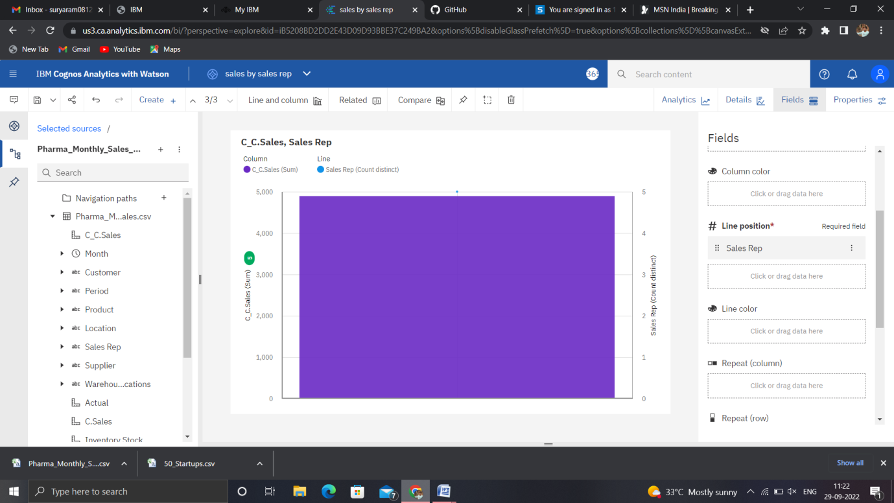

1. Received inventory from supplier

<https://us3.ca.analytics.ibm.com/bi/?perspective=explore&pathRef=.my_folders%2Freceived%2Binventory%2Bfrom%2Bsupplier&subView=model0000018387ce7f35_00000001>

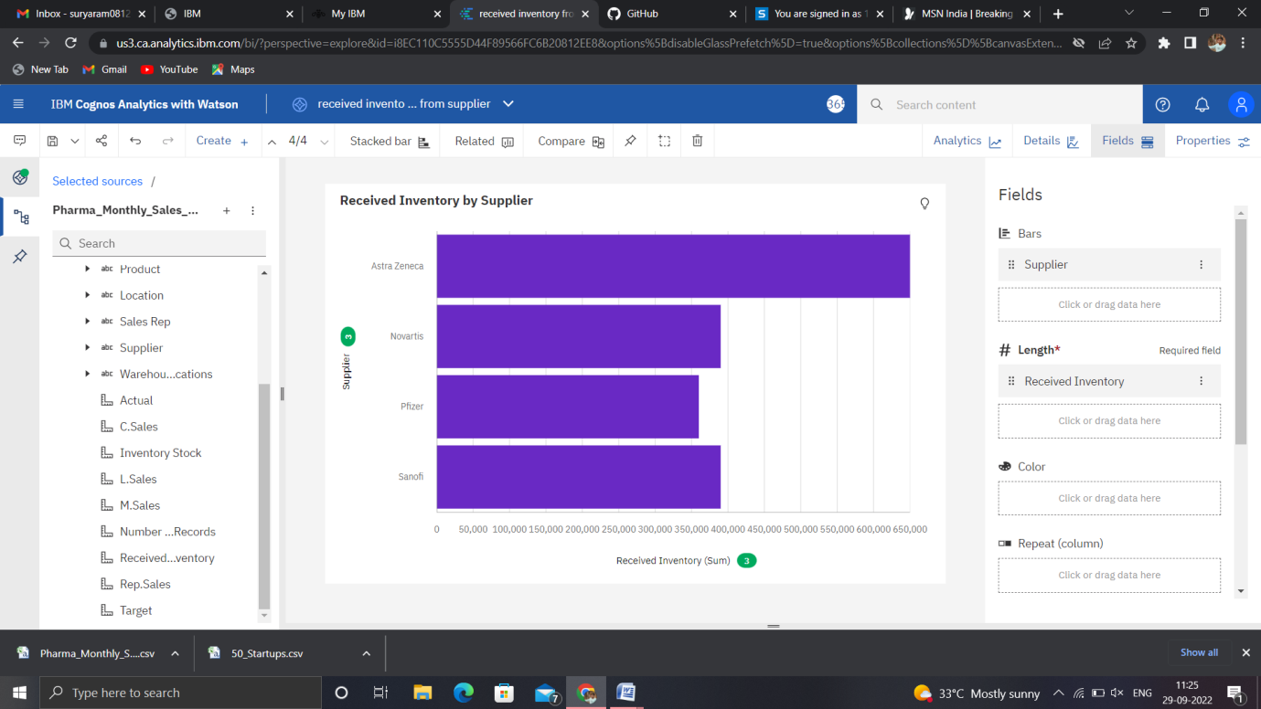

1. Inventory stock for warehouse locations

<https://us3.ca.analytics.ibm.com/bi/?perspective=explore&pathRef=.my_folders%2Finventory%2Bstock%2Bfor%2Bwarehouse%2Blocations&subView=model0000018387d2171c_00000000>

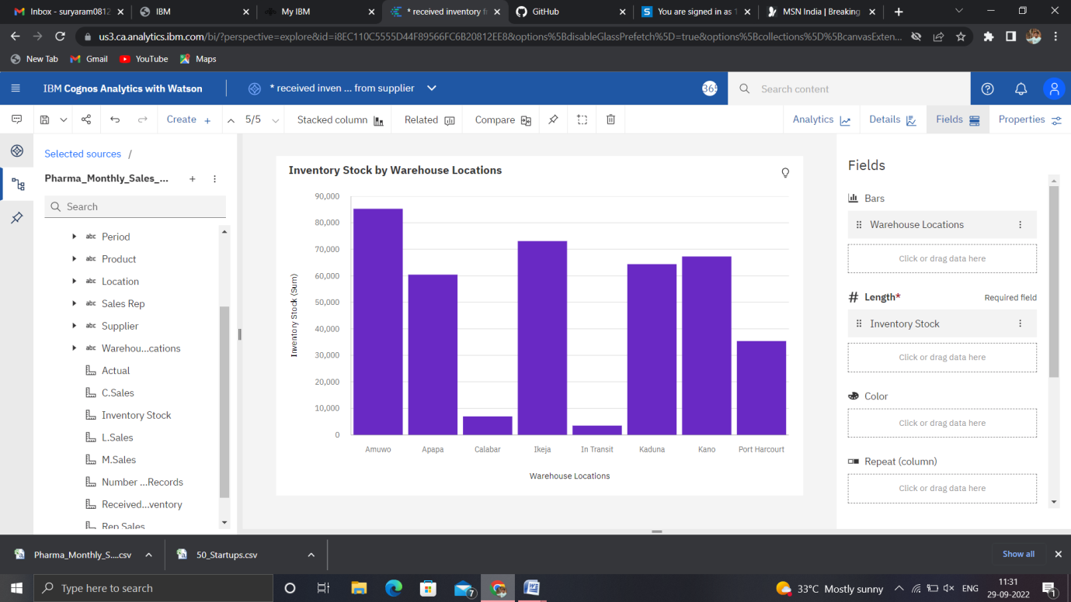

1. Sales trend

<https://us3.ca.analytics.ibm.com/bi/?perspective=explore&pathRef=.my_folders%2Fsales%2Btrend&subView=model0000018387d674cd_00000000>

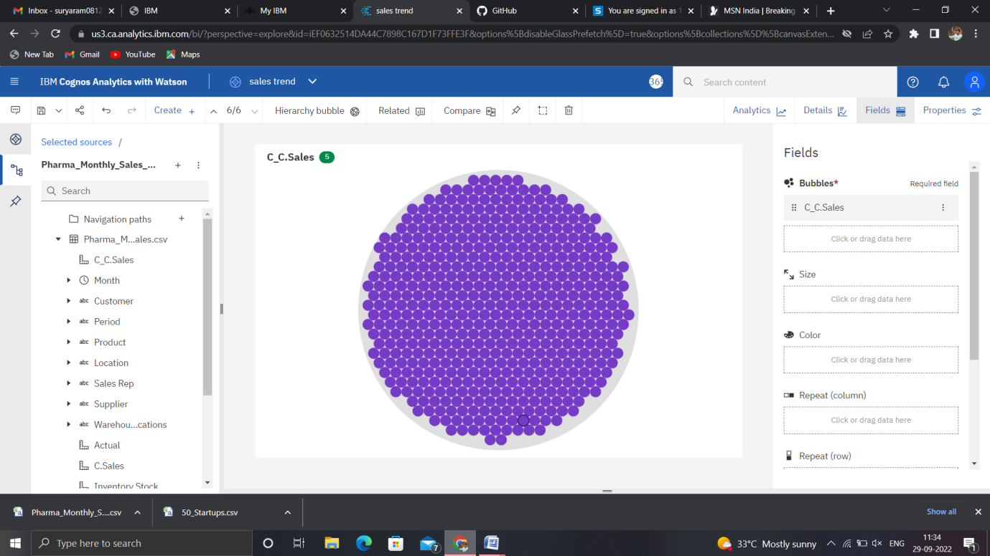

1. Monthly sales

<https://us3.ca.analytics.ibm.com/bi/?perspective=explore&pathRef=.my_folders%2Fmonthly%2Bsales&subView=model0000018387d99106_00000003>

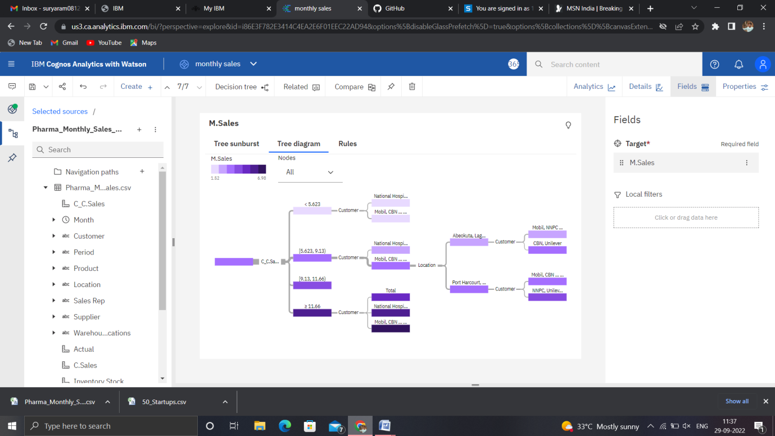

1. Actual and received inventory by month

<https://us3.ca.analytics.ibm.com/bi/?perspective=explore&pathRef=.my_folders%2Factual%2Band%2Breceived%2Binventory%2Bby%2Bmonth&subView=model0000018387db9e23_00000000>

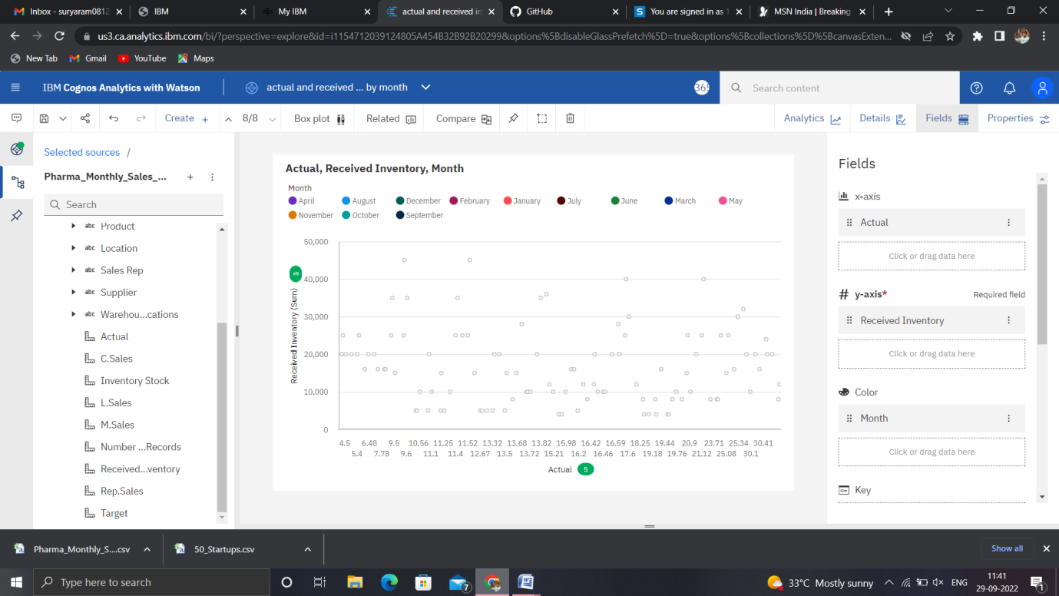

Dashboard :

<https://us3.ca.analytics.ibm.com/bi/?perspective=dashboard&pathRef=.my_folders%2FNew%2Bdashboard&action=view&mode=dashboard&subView=model0000018387e169e1_00000002>

